Linux Commands :

pwd => print working directory

ls => list file and folders

mkdir => folder

touch => make file

rmdir folder => folder should be empty

rm file => online file

cd .. => 1 folder up(before)

rm -rv folder => delete all type of folders

create a folder name as Mayank

- inside the Mayank folder

- create 6 files

- create 4 folder

- delete any 3 files

- delete any 2 folder

- check remaining files

- in last delete the Mayank folder

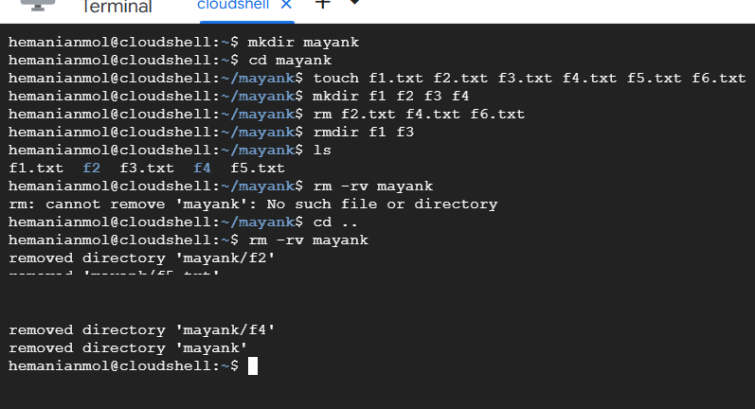

Learning assignment:

* Linux vs Unix
* Linux importance
* Command => cp and mv command